Instalar y Configurar HAPROXY – NGINX

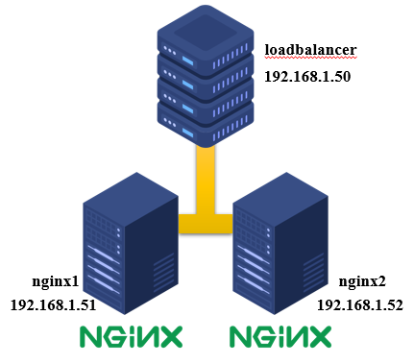**loadbalancer 192.168.1.50 (haproxy)**

**nginx1 192.168.1.51 (nginx-nodo01)**

**nginx2 192.168.1.52 (nginx-nodo02)**

**HAPROXY**

dnf install -y haproxy //instalar haproxy

cd /etc/haproxy //carpeta del haproxy

cp haproxy.cfg haproxy.cfg-orig //crear copia de seguridad del archivo

vi haproxy.cfg //editar el archivo

-----------------------------------------------------------------------

frontend http_balancer

bind *:80 //aquí va la ip del haproxy

option http-server-close

option forwardfor

stats uri /haproxy?stats

#    acl url_static       path_beg       -i /static /images /javascript /stylesheets

#    acl url_static       path_end       -i .jpg .gif .png .css .js

#    use_backend static          if url_static

default_backend nginx_webservers

backend nginx_webservers

mode http

balance roundrobin //tipo de algoritmo

option httpchk HEAD / HTTP/1.1\r\nHost:\ localhost

server nginx1 192.168.1.51:80 check

server nginx2 192.168.1.52:80 check

-------------------------------------------------------------------------

Configure rsyslog para que almacene todas las estadísticas de HAProxy, entrar al archivo “/etc/rsyslog.conf” y descomentar las líneas 19 y 20.

vi /etc/rsyslog.conf

--------------------------------------------------------------------

module(load="imudp")

input(type="imudp" port="514")

------------------------------------------------------------

systemctl restart rsyslog

systemctl enable rsyslog

Now finally start haproxy but before starting haproxy service, set the following selinux rule

setsebool -P haproxy_connect_any 1

systemctl start haproxy

systemctl enable haproxy

firewall-cmd --permanent --add-port=80/tcp //habilitar el puerto 80

firewall-cmd –reload //cargar nuevamente el firewall

**NGINX**

dnf install -y nginx //instalar nginx

systemctl start nginx

systemctl enable nginx

cd /usr/share/ngnix/html

------------------------------------------------------------------------

echo "Nginx Node01 - Welcome to First Nginx Web Server" > index.html //en los dos nodos

------------------------------------------------------------------------

firewall-cmd --permanent --add-service=http //habilitar el servicio http

firewall-cmd –reload //cargar nuevamente el firewall

**VERIFICAR**

curl 192.168.1.50 //en la ventana de comandos

http://192.168.1.50/haproxy?stats //en el navegador

**loadbalancerM 192.168.1.50 (haproxy-master)**

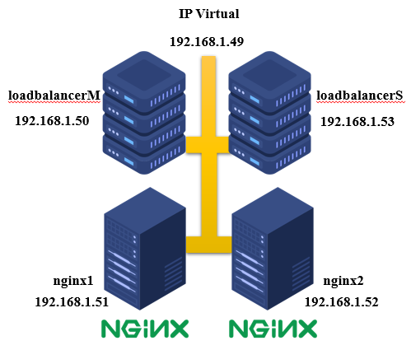**loadbalancerS 192.168.1.53 (haproxy-slave)**

**nginx1 192.168.1.51 (nginx-nodo01)**

**nginx2 192.168.1.52 (nginx-nodo02)**

**ip virtual 192.168.1.49 (keepalived)**

**HAPROXY**

Crear otra maquina virtual, y hacer la configuración del haproxy.

**KEEPALIVED**

dnf install -y keepalived //instalar keepalived

cd /etc/ keepalived //carpeta del keepalived

cp keepalived.conf keepalived.conf-orig //crear copia de seguridad del archivo

vi keepalived.conf //editar el archivo

------------------------------------------------------------------- //HAPROXY MASTER

global_defs {

notification_email {

root@mydomain.com

}

notification_email_from svr1@mydomain.com

smtp_server localhost

smtp_connect_timeout 30

}

vrrp_instance VI_1 {

state MASTER

interface ens33 //Specify the network interface to which the virtual address is assigned

virtual_router_id 51 //The virtual router ID must be unique to each VRRP instance that you define

priority 100 //Set the value of priority higher on the master server than on a backup server

advert_int 1

authentication {

auth_type PASS

auth_pass 1111

}

virtual_ipaddress {

192.168.1.49/24

}

}

----------------------------------------------------------- //eliminar los demás

--------------------------------------------------------------- //HAPROXY SLAVE

global_defs {

notification_email {

root@mydomain.com

}

notification_email_from svr1@mydomain.com

smtp_server localhost

smtp_connect_timeout 30

}

vrrp_instance VI_1 {

state SLAVE

interface ens33 //Specify the network interface to which the virtual address is assigned

virtual_router_id 51 //The virtual router ID must be unique to each VRRP instance that you define

priority 101 //Set the value of priority higher on the master server than on a backup server

advert_int 1

authentication {

auth_type PASS

auth_pass 1111

}

virtual_ipaddress {

192.168.1.49/24

}

}

----------------------------------------------------------- //eliminar los demás

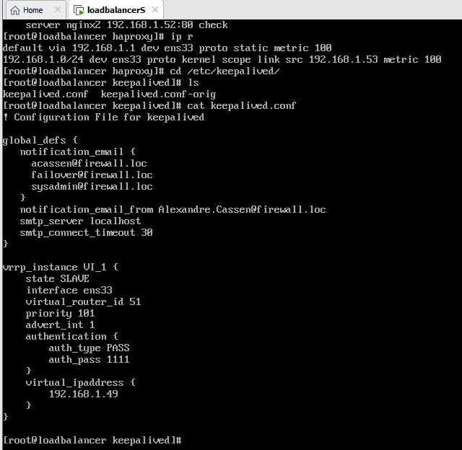

Habilitar el reenvío de IP:

echo "net.ipv4.ip_forward = 1" >> /etc/sysctl.conf

sysctl -p // net.ipv4.ip_forward = 1

systemctl start keepalived

systemctl enable keepalived

Si cambia la configuración de Keepalived, vuelva a cargar el servicio keepalived:

systemctl reload keepalived